COMP2026 Problem Solving Using Object Oriented Programming

# Laboratory 4

**Part A Discovery Exercises**

**Task 1: Command-Line Arguments**

A Java application can accept any number of arguments from the command line. This allows the user to specify configuration information when the application is launched. When an application is executed using the **java** command, Java passes the command-line arguments that appear after the class name in the java command to the application’s **main** method as an array of Strings, conventionally named **args**, in the parameter list of **main**.

The given example **CLArgsPrinter.java** prints each of the command-line arguments on a line by itself:

|  |
| --- |
| public class CLArgsPrinter {  public static void main(String[] args) {  new CLArgsPrinter().runApp(args);  }  void runApp(String[] args) {  for (int i = 0; i < args.length; i++) {  System.out.println("args[" + i + "]: " + args[i]);  }  }  } |

Compile and run the **CLArgsPrinter.java** in the Command Prompt on Windows:

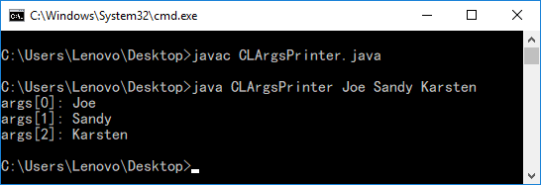

The command “**java CLArgsPrinter Joe Sandy Karsten**" passes three arguments, “Joe”, “Sandy” an “Karsten” to the application **CLArgsPrinter**. When this command executes, the **main** method receives the three-element array **args** (i.e., args.length is 3) in which **arg[0]** contains the String “Joe”, **args[1]** contains the String “Sandy” and **args[2]** contains the String “Karsten”. The programs determine how to use these arguments. In the above example, the **CLArgsPrinter** prints each of the arguments on a line by itself.

While operating upon Strings, there are times when we need to convert a number represented as a String into a number type. The wrapper classes for Java’s numeric types have some built in methods to parse a numerical value from a String. For example,

To parse an integer from String:

|  |
| --- |
| String s = "123";  int num = Integer.parseInt(s); //convert String "123" into an  //integer 123 |

To parse a double from String:

|  |
| --- |
| String s = "8.45";  double num = Double.parseDouble(s); //convert String "8.45" into   //double 8.45 |

To use command-line arguments in IntelliJ, click **Run** 🡪 **Edit Configurations**.

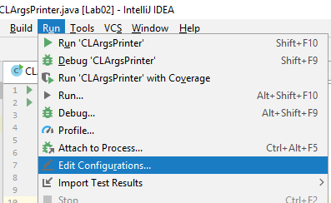

Click the green “+” button and select **Application** to create a new configuration.

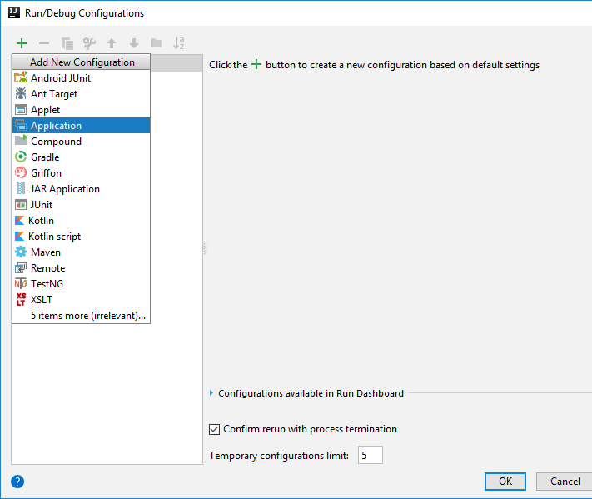

Click the “” button in Main class. Then select **CLArgsPrinter** and click **OK**.

vv

vv

vv

Type in “**CLArgsPrinter**” as the name of the configuration and type the arguments inside the **Program arguments** textbox and then click **OK**.

Run the program as usual. **Run** 🡪 **Run…** 🡪 **CLArgsPrinter**

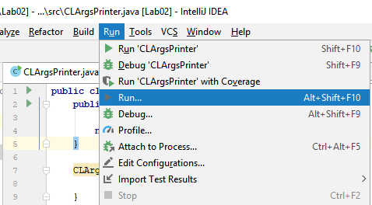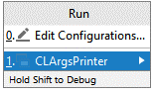

Result:

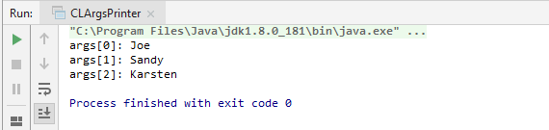

1. Compile and execute the given **CLArgsPrinter.java** program with the following program arguments and fill in the following table.

|  |  |  |
| --- | --- | --- |
| Program arguments | args.length | Values in args |
| **Joe Sandy Karsten** | 3 | args[0]: “Joe”  args[1]: “Sandy”  args[2]: “Karsten” |
| **1 2 3 4 5** | 5 | args[0]:1 args[1]:2 args[2]:3 args[3]:4 args[4]:5 |
| **HelloWorld!** | 1 | args[0]:”HelloWorld!” |
| **Chan Tai Man** | 3 | args[0]:Chan args[1]:Tai args[2]:Man |
| **"Chan Tai Man"** | 1 | args[0]:”Chan Tai Man” |

After the program is compiled by IntelliJ, the .class file is created inside the “out” folder.

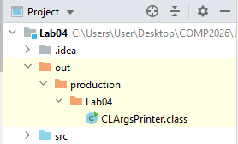

**Task 2: Array Manipulation**

Given a one-dimensional integer array **x**.

1. Write a statement to print the size of **x**.

|  |
| --- |
| int size = 0; for(int i=0; i<x.length; i++ ){  size++; } System.*out*.print(size); |

1. Write a code fragment that swaps the first and the last element in the array **x**.

|  |
| --- |
| int z = x[0]; x[0] = x[x.length-1]; x[x.length-1] = z; |

1. Write a code fragment that create a new integer array **y** which size is double of the size of **x**.

|  |
| --- |
| int []y = new int[x.length*2]; |

1. Write a loop to copy all the elements in array **x** to array **y**.

|  |
| --- |
| for(int k = 0; k < x.length; k++){  y[k]=x[k]; } |

1. The following code fragment intends to print the minimum value in an integer array **a**. Fix all the errors in the code fragment.

|  |
| --- |
| int[] a = {24, 16, 37, 5, 78}; int min = 100; for(int i = 0; i < a.length; i++){  if(a[i] < min){  min = a[i];  } } System.*out*.println(min); |

**Task 3: Enhanced for loop**

1. Rewrite the given for loop into an enhanced for loop.

Given:

|  |
| --- |
| int[] a = {2, 16, 7, 5, 8};  for(int i = 0; i < a.length; i++){  System.out.println(a[i]);  } |

Answer:

|  |
| --- |
| int[] a = {2, 16, 7, 5, 8};  for( int i : a)  System.*out*.println(i); } |

1. Given then following for loop, can you convert it into enhanced for loop? Why or why not?

|  |
| --- |
| for(int i = 0; i < a.length; i++){  a[i] = 0;  } |

Answer:

|  |
| --- |
| int[] a = {2, 16, 7, 5, 8};  for(int i : a){  i = 0; }  for(int k =0; k< a.length; k++) {  System.*out*.print(a[k]); }  No,I cant.  For the result, after we convert it into enhanced for loop, the values inside the “a” array still no change. In fact， the enhanced for loop just change the item value. |

**References**

1. Bravaco, R., & Simonson, C. (2009). *Java programming: From the ground up*. Dubuque, IA: McGraw-Hill.
2. Dean, J., & Dean, R. (2008). *Introduction to programming with Java: A problem solving approach*. Boston: McGraw-Hill.
3. Farrell, J. (2012). *Java programming. Boston, MA: Course Technology Cengage Learning*
4. Forouzan, B. A., & Gilberg, R. F. (2007). *Computer science: A structured programming approach using C (3rd ed.)*. Boston, MA: Thomson Course Technology.
5. Gaddis, T. (2016). *Starting out with Java (6th ed.)*. Pearson.
6. Liang, Y. D. (2013). *Introduction to Java programming: Comprehensive version*. (8th ed.). Pearson.
7. Schildt, H. ( 2006). *Java a beginner's guide*. New York: McGraw Hill.
8. Schildt, H., & Skrien, D. J. (2013). Java programming: A comprehensive introduction. New York: McGraw-Hill.
9. Wu, C. T. (2010). *An introduction to object-oriented programming with Java*. Boston: McGraw Hill Higher Education
10. Xavier, C. (2011). *Java programming: A practical approach*. New Delhi: Tata McGraw Hill.
11. yet another insignificant Programming Notes. (n.d.). Retrieved from https://www3.ntu.edu.sg/home/ehchua/programming
12. Zakhour, S., Kannan, S., & Gallardo, R. (2013). *The Java tutorial: A short course on the basics (5th ed.)*.